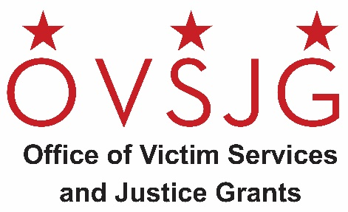

NOTICE OF FUNDING AVAILABILITY (NOFA)

FISCAL YEAR 2023 (FY23)

Special Education Legal Services for Emerging Adult Defendants RFA

The Office of Victim Services and Justice Grants (OVSJG) announces the availability of FY 2023 grant funds for a legal services and advocacy organization serving older youth with special education needs who are involved in the District’s juvenile and criminal legal systems. Up to $300,000 is available to provide special education legal representation to emerging adult defendants with disabilities.

For the purposes of this funding opportunity, emerging adult defendant with a disability means a criminal defendant under 23 years of age, or the parent, as that term is defined in 20 USC Section 1401(23), of a criminal defendant under 18 years of age who is:
- Charged as an adult; and
- Qualifies as a child with a disability, as defined in 20 USC Section 1401(3)

Eligible Organizations/Entities: Any public or private, community-based non-profit agency, organization, or institution located in the District of Columbia is eligible to apply, including District government agencies. For profit organizations are eligible but may not include profit in their grant application. For-profit organizations may also participate as subcontractors to eligible agencies.

Anticipated grant award period: May 1, 2023 to September 30, 2023

Application Submission Deadline: Friday, March 31, 2023

The Request for Applications (RFA) will be available electronically beginning Wednesday, March 1, 2023 at https://ovsjg.dc.gov/page/funding-opportunities-current and the District’s Grant Clearing House website at https://communityaffairs.dc.gov/content/community-grant-program. All applications must be submitted to OVSJG’s online grants management portal, ZoomGrants™.

For additional information regarding this grant competition, please email ovsjg.justicegrants@dc.gov with the subject line reference “FY 2023 Special Education Legal Services for Emerging Adult Defendants RFA.”

