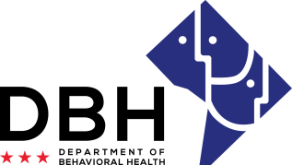
District of Columbia Opioid Response (DCOR) Grant Opportunities
RFA # RM0 DOR012221

Intent to Apply Notification
Due Date: Tuesday, January 26, 2021

TO: Department of Behavioral Health, Grants Management Office
www.dbh.grants@dc.gov

FROM:
Name of Organization

RE: Intent to Apply for District of Columbia Opioid Response (DCOR) Grant Opportunities

Please select all applicable competitions applied for:
Competition 1: Faith-Based Prevention ☐Yes ☐No
Competition 2: Pregnant/SUD Screening ☐Yes ☐No
Competition 3: Pregnant/SUD Treatment ☐Yes ☐No
Competition 4: Hospital Based Naloxone Training ☐Yes ☐No
Competition 5: Comprehensive Case Management ☐Yes ☐No

Organization Address:
Contact Person/Title:
Contact Person Telephone Number:
Contact Person Email:

This notification serves as intent to apply for the abovementioned Request for Application. The notification is due Tuesday, January 26, 2021 to dbh.grants@dc.gov. Notifications are to be sent to this email address only and will not be received via telephone, fax, email (other than address noted) or in-person.

I am also confirming attendance at the mandatory pre-application conference being held January 29, 2021.
#Attendees:
Webinar: ☐Yes ☐No

Print Name Date

Signature

