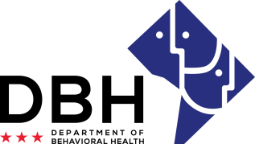
District of Columbia Opioid Response (DCOR2) Grant Opportunities
RFA # RM0 DOR092520

Intent to Apply Notification
Due Date: Tuesday, September 29, 2020

TO: Department of Behavioral Health, Grants Management Office
www.dbh.grants@dc.gov

FROM:
Name of Organization

RE: Intent to Apply for District of Columbia Opioid Response (DCOR2) Grant Opportunities

Please select all applicable competitions applied for:
Competition 1: Hospital-Based Peers ☐Yes ☐No
Competition 2: Crisis Stabilization ☐Yes ☐No
Competition 3: Peer-Operated Centers ☐Yes ☐No
Competition 4: Peer Recovery Housing ☐Yes ☐No
Organization Address:
Contact Person/Title:
Contact Person Telephone Number:
Contact Person Email:

This notification serves as intent to apply for the abovementioned Request for Application. The notification is due Tuesday, September 29, 2020 to dbh.grants@dc.gov. Notifications are to be sent to this email address only and will not be received via telephone, fax, email (other than address noted) or in-person.

I am also confirming attendance at the mandatory pre-application conference being held October 2, 2020.
#Attendees:

Print Name Date

Signature

