GOVERNMENT OF THE DISTRICT OF COLUMBIA
Executive Office of the Mayor
OFFICE OF VICTIM SERVICES AND JUSTICE GRANTS
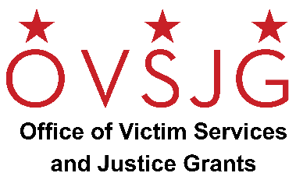

NOTICE OF FUNDING AVAILABILITY

Fiscal Year 2023
Consolidated Victim Services
Request for Applications

The Office of Victim Services and Justice Grants (OVSJG) announces the availability of crime victim services grant funding for FY 2023.
Purpose/Description:
The Office of Victim Services and Justice Grants announces the availability of grant funds under the Fiscal Year 2023 consolidated funds to enhance and maintain a comprehensive network of trauma informed services available for victims of crime; to address the issues of domestic violence, dating violence, stalking, and sexual assault in a manner that promotes victim safety and offender accountability; to improve the treatment of victims of crime by providing them with the assistance and services necessary to aid their restoration after a violent criminal act; and to support and aid them as they move through the criminal and civil justice processes.

Funding in this RFA includes:
Local, Crime Victim Assistance Fund, American Rescue Plan Act (ARPA), Victims of Crime Act (VOCA) Grant, STOP Violence Against Women (STOP) Grant, Sexual Assault Services Program (SASP) Grant, Family Violence Prevention and Services Program (FVPSA) Sexual Assault and Rape Crisis Services and Supports Grant.

Eligible Organizations/Entities: Any public or private, community-based non-profit agency, organization, or institution located in the District of Columbia is eligible to apply. For-profit organizations are eligible for local funds but may not include profit in their grant application. For-profit organizations may also participate as subcontractors to eligible agencies.

Length of Award: The grant award is for Fiscal Year 2023. The funding period is October 1, 2022 – September 30, 2023.

RFA Release: The Request for Applications (RFA) will be available electronically beginning Monday, April 25, 2022 on the OVSJG website at http://ovsjg.dc.gov and the District’s Grant Clearinghouse website at https://communityaffairs.dc.gov/content/community-grant-program#4. All applications must be submitted to OVSJG’s online grants management portal, ZoomGrants™.

Application Submission Deadline: 11:59 PM ET Monday, June 6, 2022.

For additional information regarding this grant competition, please email ovsjg.victimservices@dc.gov with the subject line reference “FY23 Consolidated Victim Services RFA.”

