GOVERNMENT OF THE DISTRICT OF COLUMBIA
Executive Office of the Mayor
OFFICE OF VICTIM SERVICES AND JUSTICE GRANTS
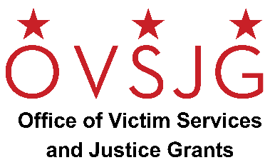

NOTICE OF FUNDING AVAILABILITY

Fiscal Year 2022
Transportation for Individuals Released from the District’s Central Cell Block and DC Superior Court
Request for Applications

The Office of Victim Services and Justice Grants (OVSJG) announces the availability of FY 2022 grant funds for a community-based organization to provide transportation for individuals released from the Central Cell Block and DC Superior Court.

Purpose/Description:
$100,000 is available to support transportation costs for individuals released from the District’s Central Cell Block and DC Superior Court. OVSJG anticipates making one award.

Eligible Organizations/Entities: Any public or private, community-based non-profit agency, organization, or institution located in the District of Columbia is eligible to apply. For-profit organizations are eligible but may not include profit in their grant application. For-profit organizations may also participate as subcontractors to eligible agencies.

Length of Award: The grant award is for Fiscal Year 2022. The funding period is February 1, – September 30, 2022.

RFA Release: The Request for Applications (RFA) will be available electronically beginning Monday, January 3, 2022 on the OVSJG website at http://ovsjg.dc.gov and the District’s Grant Clearinghouse website at https://communityaffairs.dc.gov/content/community-grant-program#4. All applications must be submitted to OVSJG’s online grants management portal, ZoomGrants™.

Application Submission Deadline: Wednesday, February 2, 2022.

For additional information regarding this grant competition, please email ovsjg@dc.gov with the subject line reference “FY22 Transportation RFA.”

