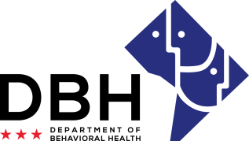
District of Columbia Opioid Response (DCOR2) Grant Opportunities
RFA # RM0 DOR092520

Notice of Eligibility and Experience Requirements for Competition 1: Hospital-Based Peers

Eligibility Requirements
Applicants must meet the stated eligibility and performance requirements in the RFA. Please describe your organization’s eligibility in the applicable box below. You may include supporting documents.

1. Eligible entities who can apply for grant funds under this RFA are:
A not-for-profit organization located in the District of Columbia (DC) and licensed by the DC Department of Client and Regulatory Affairs (DCRA) to conduct business.

Justification:

Able to enter into an agreement with DBH requiring compliance with all governing federal and District of Columbia laws and regulations, including Substance Use Disorders and Mental Health Grants (22-A DCMR Chapter 44).

Justification:

Experience Requirements
2. Eligible entities who can apply for grant funds under this RFA should have the following experience:
At least two (2) years of experience in implementing OUD treatment or recovery support services.

Justification:

Proof (i.e., letter of commitment or memorandum of understanding) that the organization has a formal affiliation with seven (7) local acute care hospitals.

Justification:

Demonstrated ability to start work within thirty (30) calendar days of award.

Justification:

Experience managing multiple grants or contracts greater than $100,000.00.

Justification:

Experience managing local (District of Columbia) or federal grants.
Justification:

A functioning accounting system that is operated in accordance with generally accepted accounting principles.

Justification:

